**KIBUUKA MIXED PRIMARY SCHOOL – NANSANA**

**TOP CLASS ENTRY INTERVIEW 2022**

**Name: ……………………………………………………………………….**

**Class: ……………………………………… Date: ………………………..**

1. **Name the shapes.**

____________ ___________

____________ ___________

(rectangle, triangle, circle, square)

1. **Draw balls for the number.**

6 = 4 =

2 = 8 =

10 =

1. **Add the beads.**

+ =

+ =

1. 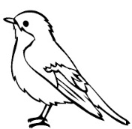**Read and match.**

dog

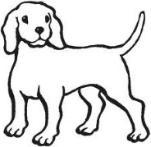

bed

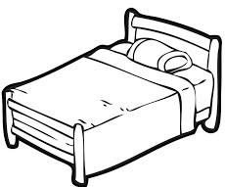

bird

1. 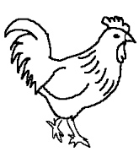**Name these.**

______________ hill

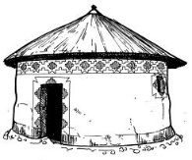 ______________ hut

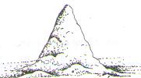

_______________ hen



_______________ hat

1. **Ring words with sound “o”.**

hat bag on

of can cot

at ox up

***\*\*\*Good Luck\*\*\****